Japonisme

The term Japonisme refers to the reception of Japanese art products and stylistic forms in Europe and the United States beginning in the second half of the 19th century and continuing until the early 20th century. Japonisme involves the collecting of Japanese products by Western artists and art lovers as well as the adaptation of East Asian motifs and forms for the creation of pictures and objects. Paris was the centre of early Japonisme; the first collectors were art critics such as Ernest Chesneau or Philippe Burty. The painters Edouard Manet and James Abbott McNeill Whistler were early enthusiasts of Japanese arts and crafts. The opening up of new possibilities for representation, mediated by Japanese colour woodcuts from artists such as Utagawa (Andō) Hiroshige, had a profound effect on artistic schools ranging from Impressionism to Expressionism. Not only the means of Japanese design, but also the egality of the represented subjects, the equal treatment of nature, animals and human beings, of high art and handicraft, helped Western artists to overcome their academic traditions. Japonisme as an artistic and visual movement undertook a trans-cultural appropriation of the Japanese stylistic language, which contributed to the breakthrough of modern art in the West.

The centre of development for early Japonisme was Paris. After a rigorous restriction on overseas trade that had existed since the end of the 16th century, Japan re-opened to the Western market in 1854 and began exporting its own products. Japanese woodcuts by artists such as Katsushika Hokusai, Hiroshige, Kitagawa Utamaro, Suzuki Harunobu, and Hishikawa Moronobu drew great interest in France, where they initially arrived as packing material for export goods such as tea or ceramics. The prints — also referred to as ukiyo-e, meaning images of a serene, evanescent world — were received with great enthusiasm by writers and art critics such as the brothers Edmond and Jules de Goncourt, Philippe Burty, and Ernest Chesneau. In 1872, Burty coined the term Japonisme in the journal La Renaissance littéraire et artistique.

Early Japonisme enthusiasts — for example Manet, Whistler, and Edgar Degas — were supplied with Asian products of all kinds by Parisian stores like the Jonque Chinoise or the Porte Chinoise. The colour woodcuts especially served as a source of inspiration for the development of their own artistic work. The abstraction of basic shapes; displacement, rotation, and foreshortening, and variable enlargement of the motifs; the different scales within a single depiction; and the mostly flat pictorial space occurring in the prints opened a way out of the stylistic crisis of many European artists. Edmond de Goncourt noted in his diary in 1884 that “no more and no less than a revolution in the seeing of the European people, this is Japonisme.”

From the artistic community’s enthusiasm in the 1850s and 1860s, a broad movement developed in Europe and North America in the following decades. The importation of handcrafted goods from Japan was systematized and improved. The most successful trader of East Asian art was the merchant Samuel (Siegfried) Bing, who founded the journal Le Japon artistique in 1888. The importance of Japonisme for modern art can be followed beyond the turn of the century, in the work of artists such as Claude Monet, Vincent Van Gogh, Gustav Klimt, Franz Marc, and Pablo Picasso.

References and further reading

Irvine, G. (2013) Japonisme and the rise of the modern art movement: the arts of the Meiji period, The Khalili Collection, London: Thames & Hudson.

Weisberg, G. P., ed. (2011) The Orient expressed: Japan’s influence on Western art, 1854-1918, Seattle, Washington et al.: University of Washington Press.

Wichmann, S. (2007) Japonisme, The Japanese influence on Western art since 1858, London: Thames & Hudson.

Ono, A. (2003) Japonisme in Britain: Whistler, Menepes, Henry, Hornel and the nineteenth-century Japan, London: RoutledgeCurzon.

Berger, K. (1980) Japonismus in der westlichen Malerei, 1860-1920, Munich: Prestel.

Images

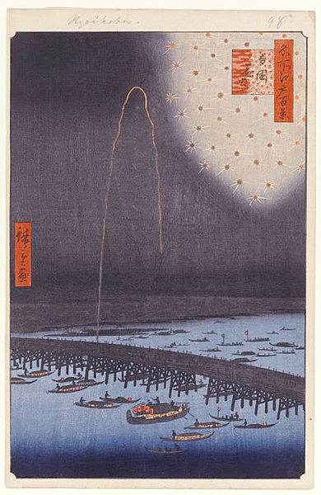

Utagawa (Andō) Hiroshige, Fireworks at Ryogoku Bidge (Ryogoku Hanabi), No. 98 from One Hundred Famous Views of Edo (Meisho Edo Hyakkei), 1858, colour woodcut, 36.2 x 23.5 cm (sheet), 34 x 22.5 cm (image), Brooklyn Museum, Gift of Anna Ferris (Accession No. 30.1478.98)
https://www.brooklynmuseum.org/opencollection/objects/121712/Fireworks_at_Ryogoku_Ryogoku_Hanabi_No._98_from_One_Hundred_Famous_Views_of_Edo

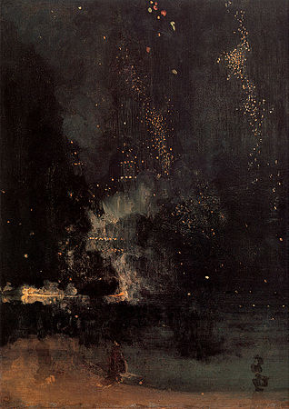

James Abbott McNeill Whistler, Nocturne in Black and Gold, The Falling Rocket, 1875, oil on panel, 60,2 x 46,7 cm, Detroit Institute of Arts, Gift of Dexter M. Ferry, Jr. (Accession No. 46.309)
http://www.dia.org/object-info/7d1a59d3-6163-440a-925a-b0978f1f8811.aspx

